Vanessa Rickertsen
Dr. Sassi
Young Adult Literature
11/27/17
Diary vs. Diary: Teaching Sherman Alexie’s Absolutely True Diary of a Part-Time Indian in conjunction with Jeff Kinney’s Diary of a Wimpy Kid

Introduction
Many educators, like Julie Bolt, Jeanne McGlinn, Kenan Metzger, and C. Zitzer-Comfort, agree that Indigenous Literature should be taught in schools, but how? Joan F. Kaywell argues for using young adult literature “in conjunction with the classics” to “expose students to reading that becomes relevant and meaningful” (ix); similarly, I suggest IYAL be taught in tandem with more mainstream/dominant culture YAL to build connections between the genres and foster greater understanding of the themes addressed in each book and their cultural influence and impact . Sherman Alexie’s Absolutely True Diary of a Part-Time Indian and Jeff Kinney’s Dairy of Wimpy Kid provide an excellent opportunity for this method. Both books were published in 2007, similar story-telling techniques such as humor and illustration, and have protagonists close in age, although Alexie’s main character is a little older and the book has an overall tone that is geared for an audience a few years older than Kinney’s.
This essay will provide a number of themes and topics to discuss about the two books. Depending on the grade level (I would suggest 8th grade and up) and focus of the class, teacher may want to cover more topics at a quicker pace or focus in on a few topics at a more in-depth level. For each of the topics, teachers can use activities and/or discussion based in a compare/contrast format for students to analyze how each narrative approaches the topic. Students can also compare the books to their own personal experiences to create a triangular and relatable sense of understanding.

Summaries of the Works

Absolutely True Diary of a Part-Time Indian by Sherman Alexie
Partially inspired by his own experience, Sherman Alexie tells the story of Arnold Spirit Jr., aka Junior, a Spokane Indian born with a number of medical conditions that left him a stutter, lisp, near-sighted in one eye, and far-sighted in the other. Junior’s best friend is Rowdy, “the toughest kid on the rez. He is long and lean and strong like a snake. His heart is as strong and mean as a snake, too” (15). While Rowdy does not outwardly express his appreciation for Junior, he still protects him from bullies. Junior and Rowdy are about to enter their first year at Wellpinit High School and Junior, who loves school, especially math, is excited. That is, until he receives a Geometry book on the first day of class that is so old his mother has signed it when she was a student. This leads to a series of events that involve breaking a teachers nose, a heart-to-heart with said teacher, and finally a decision to transfer to Reardan, an all-white school off the reservation. Nearly everyone on the rez feels that Junior is a traitor and even Rowdy turns his back on Junior. At Reardan, Junior struggles with his identity and new life, but also makes new friends like Gordy, Roger, and Penelope (who eventually becomes his girlfriend). Tragedy strikes repeatedly: Junior’s grandmother is struck and killed by a drunk driver, his father’s friend Eugene (who would sometimes give Junior rides to/from school) is shot and killed over a nearly empty bottle of alcohol, and Junior’s sister Mary (who got married and ran away earlier in the story) is killed in a trailer house fire after passing out drunk. Despite this, Junior continues to push through his freshman year at Reardan. The story ends in a moment of reconciliation between Rowdy and Junior.
Diary of a Wimpy Kid by Jeff Kinney
Kinney’s story follows the life of Greg Heffley over his first year of middle school. While his father wishes he would spend time outside or play sports, Greg prefers to stay inside all day and play video games. Greg’s main concern going into school is his popularity, which he is severely lacking (but not at the bottom). His best friends is Rowley, a much less popular students who Greg befriended a few years prior out of pity. Greg feels Rowley may damage his image, so he keeps at arm’s length at the start of the year. At home, Greg deals with his older brother, Rodrick, and younger brother, Manny, neither of which he is very loving towards. Rodrick constantly pulls pranks on Greg and makes fun of him while Manny is spoiled by their parents. Through the school year, Greg deals with the wrestling unit in Phys Ed, an unwilling part in the school play, and the every fickle castes of middle school popularity. Greg and Rowley sign up to be Safety Patrols to avoid being picked on at school, which came with the additional perks of missing twenty minutes of math class, free hot chocolate, and being ten minutes late to first period. One of the responsibilities of being a safety patrol is to walk kindergarteners home, which Greg takes as an opportunity to have “fun” by chasing the children with a worm on a stick, an event that was reported to the school. However, the reported thought it was Rowley, not Greg, who terrorized the children, a mistake that Greg did not correct and let Rowley take the fall for. Once Rowley finds out the truth, he sets the record straight, which causes Greg to lose his position as a Safety Patrol and creates a rift in their friendship. Rowley’s popularity continues to grow when he is selected as the new cartoonist for the school newspaper. The book ends in an escalation of events where Greg and Rowley confront one another and nearly start a fight before a group of high school bullies show up and force Rowley to eat an infamous piece of moldy cheese. If the other students found out what happened, Rowley’s image would be severely damaged. Students start to catch on that the cheese is gone and Greg and Rowley were the last one’s near the cheese. Greg claims that he picked up the cheese and threw it away, taking on the cursed “Cheese Touch” that comes along with touching the cheese. Rowley is grateful that Greg chose to cover for him and their friendship is mended.
Critical Multicultural Analysis
While Greg and Junior may follow a similar character arc when the stories are stripped down to the bones, the meat of their stories, the reality and details of their situations, create vastly different experiences. While the books share many themes, how they are address varies, often a result of culture. Maria José Botelho and Masha Kabakow Rudman offer a wonderful platform for critically reading these books in Critical Multicultural Analysis of Children’s Literature:
Critical multicultural analysis is reading power and exposing how power is exercised, circulated, negotiated, and reconstructed. Children’s books are windows into society and he complexities of the power relations of class, race, and gender. Critical multiculturalism underpins this kind of analysis because it respects diversity and uses it as a resource for learning, by going beyond affirmation to solidarity and critique, and by examining hegemony and issues of social power. (117)
While some of the more complex levels of analysis available through this theory may be beyond a high school level, the basic idea of tracking power is something students of that level could work through. Power can mostly be seen through the themes of Friendship & Loyalty and School & Education. Race and class create prevalent differences in many of the aspects in Junior and Greg’s lives, which can be seen in nearly all of the themes throughout the books.

Friendship & Loyalty
Friendship and loyalty that many teens and young adults struggle and experience change in. Junior and Greg both encounter changing dynamics of friendship, specifically the loss then eventual reconciliation with a best friend. However, the types of friendships that Junior and Greg have are very different. True to the overall lighter-hearted mood of Wimpy Kid, Greg has a more surface level friendship with his best friend compared to the more personal connections that Junior makes. Even so, the parallels between the two depictions of friendship provide a great platform for discussion and comparison.
Both Greg and Junior both lose their best friend due to a selfish purpose, the major difference being that Junior’s reason for transferring schools was about seeking a better life which is not an inherently selfish thing, whereas Greg was purely selfish in not wanting to lose his privileges. In Junior and Rowdy’s friendship, Rowdy has power over Junior, especially at the beginning of the book. Rowdy can physically protect, or injure, Junior. However, Junior does have some power, but in a different way. Junior takes the initiative to better his live by switching schools, something that Rowdy is unable to do. Junior builds his own agency by creating a way off the reservation for himself. Between Greg and Rowley, it is Greg who initially has power. For Greg and Rowley, agency comes in the form of popularity. Near the beginning of the book, Greg claims to rank “52nd or 53rd” most popular while he places Rowley “around the 150 mark.” There is a shift in power dynamic when Greg is stripped of his privilege of Safety Patrol when Rowley turns him in. The dynamic is further skewed when Rowley’s comics become a sensation, but ultimately Greg and Rowley end up on a level ground of power with the concluding events of the story.

Junior/Arnold & Rowdy (Part-Time Indian)
- Friends from birth (born the same day), invested in each other’s personal lives
- Friendship is broken off when Junior ‘betrays’ Rowdy by transferring to the white school, Rowdy beats up Junior for it
- At the end of the book they reconcile, Rowdy is okay with Junior leaving and says that’s what he was meant to do

Greg & Rowly (Wimpy Kid)
- Became friends because Greg felt sorry for Rowly when he was new to the neighborhood
- Friendship is broken off after Greg lets Rowly take the blame for something he did, Rowly is upset and starts hanging out with a new friend
- Towards the end of the book, the two reconcile after they are bullied by a group of high school students

Greg and Junior both take different approaches to making new friends after losing their respective best friends and have varying degrees of success. Junior loses Rowdy in a move that simulations leads him to a new school where he is not only singled out because of his race, but also is now at the bottom of the socio-economic ladder. Junior’s new friends all have power over him due to the social constructed concepts of race and class. However, Junior is able to gain agency through respect and apathy, and ultimately creates fulfilling relationships with his new peers at Reardan. In contrast, Greg is felt leaving lonely after Rowley starts spending time with someone else. Greg attempts to befriend a classmate who Greg has social standing over. Greg is manipulative and attempted friendship fails almost immediately.

Junior/Arnold & Gordy, Roger, and Penelope (Part-Time Indian)
- Junior’s friends at Reardan
- Junior punches Roger, but Roger doesn’t fight back, instead he gives Junior some level of respect for it
- Gordy and Junior became friends because they were both “lonely and sad and isolated and terrified” (94), never super close, but still friends
- Junior is enamored with Penelope, the two become close and even date after Junior discovers her secret of being bulimic
- Roger and Penelope feel sympathy for Junior and the fact that his family is poor
- All three stand up for Junior after he is called out by a teacher for missing school

Greg & Fergley (Wimpy Kid)
- Lives in the neighborhood, paired with Greg in gym class
- Greg reluctantly tries to befriend Fergley to make Rowley jealous after he starts hanging out with another kid from school
- Fergly makes Greg uncomfortable, Greg runs away from Fergly’s house in the middle of the night and does not make any further attempt to make new friends

Here are some guiding questions to ask students or base activities on relating to friendship and loyalty:
- How would you describe the types of friendships Junior makes? How about Greg?
- What characteristics does each character look for in a friend? What characteristics do you look for in a friend?
- How do Greg and Junior treat their friends? How do their friends treat them?
- How might culture affect Greg and Junior’s views of friendship?
- What does loyalty mean to you? What role does it play friendship?
- How do race, class, and power impact friendships for Greg and Junior?

Family
Family is an extremely important part of every person’s life, for better or for worse. Both Alexie and Kinney’s narrative include aspects of family, specifically parents, siblings, and a grandmother. Overall, Junior is very close to his family and clearly cares deeply about them. In contrast, Greg is rather indifferent or even antagonistic towards his family. The importance and representation of family is something that differs from indigenous YAL and mainstream YAL; family, parents in particular, play a minimal role in traditional YAL whereas in indigenous YAL family plays an important role and often help in guiding the main character’s choices and personality traits. For Greg and Junior, their parents very different roles. For Junior, they are vital to his existence and he constantly is grateful for them. Junior was raised in a culture that values family, and it shows in how he treats his family members and how his family members impact his life. In contrast, Greg has much less connection to his family and they have much less of an impact on Greg’s character.

Junior & His Parents
- When Junior choses to transfer schools, his parents are hesitant but ultimately supportive
- Junior cares very deeply for his parents, he even says his parents are “the twin suns around which I orbit and my world would EXPLODE without them” (11)

Greg & His Parents
- Generally just doesn’t care for his parents
- Mostly annoyed with them
- Does little to show appreciation for his parents, like when they go out of their way to buy an expensive Christmas present for Greg that he previously wanted but no longer has interest in

While parents are the largest familial relation in each book, Kinney and Alexie both chose to also include siblings in their stories. Mary is not physically present in the narrative for Junior the way Rodrick and Manny are for Greg, but she has a greater emotional impact. While not every student will have siblings, those who do will have vastly different experiences and even those who don’t have siblings will have observed sibling relationships around them.

Junior & Mary
- Junior admires his sister, even after she runs away to Montana
- Extremely upset by her death

Greg & Rodrick and Manny
- Dislikes both of his siblings
- Is jealous of his younger brother and is embarrassed by him
- Doesn’t relate to his older brother, sees him as an enemy out to get him

Extended family tends to have little to no presence in YA literature. Coincidently, both Alexie and Kinney include a grandmother in their stories. Junior’s grandmother was a symbol of tradition and compassion on the reservation, and her death was impactful event in the community. Greg’s grandmother was only briefly mentioned and played little role in the events of the story.

Junior & Grandmother Spirit
- Junior is inspired by his grandmother and her death brings the community together

Greg & Grandma
- Uses his grandma’s house as an escape and doesn’t feel all that bad when it gets TP’s the next day

Here are some guiding questions to ask students or base activities on relating to family:
- What is family? Who do you consider family?
- How is family represented in each book?
- What role does family play in your life? How does that compare to Greg and Junior’s families?
- What role does Junior play in his family? What role does Greg play? What role do you play in your family?
- How does family shape us? What impact does it have on our characteristics, choices, and morals?
- How might culture impact the value of family?

School & Education
School is going to be a major aspect of life for all of your students at this point in their lives. Every student is going to have a different experience in their education, whether positive, negative, or mixed. The main characters of these two works are a few grades apart, but are in a similar age group. Their depictions and value of school are very different. Junior is extremely motivated in his education and active in his learning, and is so devastated by the limitations of Wellpinit’s lack of funding that he throws a textbook at his teacher’s face. By transferring schools, he is creating for himself an opportunity to get off the reservation and eventually build a better life than he would have been able to if he had stayed at Wellpinit. In addition to education, basketball is a major part of school for Junior. Basketball is a very big part of life on many reservations, an example of this vast impact can be seen in the Lakota Nation Invitational (LNI), which brings in tens of thousands of people to Rapid City, SD every year. Junior is dedicated to playing basketball at his new school, even though they must play his former classmates. In contrast, Greg seems to care minimally about his education and only goes to school because he has to. Education is inconsequential to him as he already has a decent life and has nowhere to escape from. Because Greg is from a middle class white family, he does not need to rely on his education to create a decent platform for his future. Greg has no involvement in extracurricular activities and prefers to spend his time outside of class at home playing video games.

Junior
- Ostracizes himself from his community in order to switch to a different school where he can get a better education
- Mentions of Native American boarding schools
- Pushes himself to succeed to make a future for himself

Greg
- Indifferent about the educational aspect of school
- Is smart but tries to get put in the ‘dumb’ reading group so he can slack off
- Agrees to be a Safety Patrol because he can miss part of his math class

Here are some guiding questions to ask students or base activities on relating to school and education:
- How do Greg and Junior differ in their feelings about school? Why do they have the feelings they do?
- How does school benefit Junior? How does it benefit Greg?
- What it is the importance of basketball for Junior?
- How is Greg’s privilege apparent when it comes to education?
- What roll does education play in your life? What do you aim to get out of it? Is it something you have to do, have the right to do, or the privilege to do?
- How do Wellpinit and Reardan vary in the education they provide? What causes that difference?

Drawing & Illustration
Drawing can be used for a variety of purposes; entertainment, production and sale, and self-expression are a few. Both Greg and Junior enjoy drawing and call themselves cartoonist, but they had different motivations and produce very different content. Junior feels that drawing is part of his identity and is how he chooses to communicate with the world. Greg simply enjoys drawing and finds it as a way to entertain himself.

Junior
- “I draw because I want to talk to the world. And I want the world to pay attention to me” (6)
- Writes comics and creates drawing to depict the struggles of his life including race, poverty, death, family, friends, and life on a reservation; uses a humoristic lens to discuss the very real and serious issues he faces
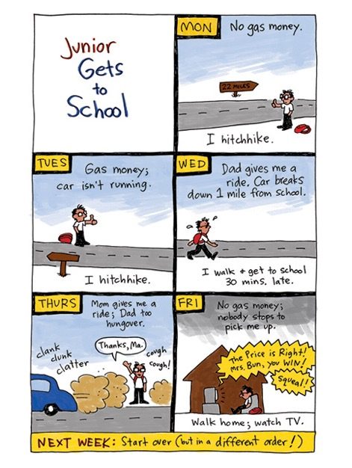
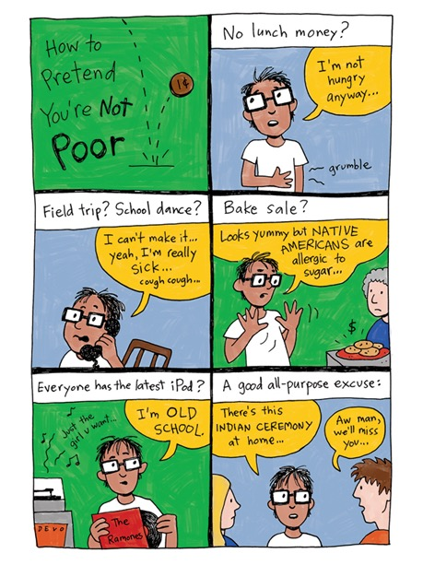

Greg
- Wants the job as a cartoonist at the school newspaper so he can gain popularity
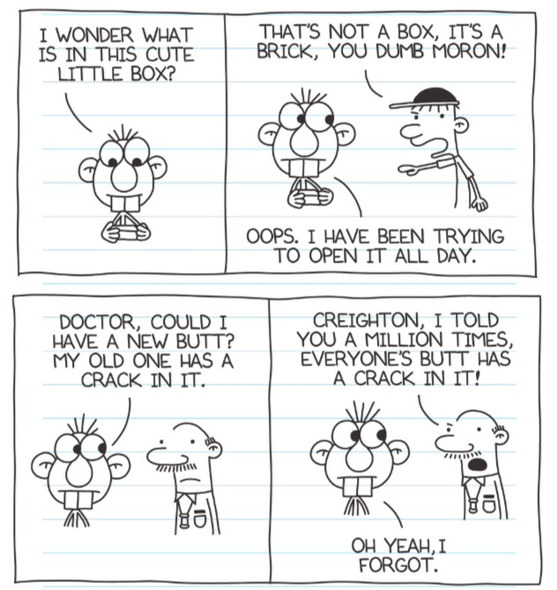
- Draws comics that he thinks are funny, rather minimalistic and inconsequential

Botelho and Rudman claim that “Illustrators can experiment with different ways of rendering the cultural experience described in the text… color, line, and the spatial position of the characters shape the reader’s view of the events depicted” (293) Like Junior and Greg, Alexie and Kinney use illustration is different ways as well.

Alexie
- Part of the storytelling, ‘drawn’ by Junior
- Variety of artistic techniques and types of illustrations
- Not always a direct translation of the text, but rather an addition to the story
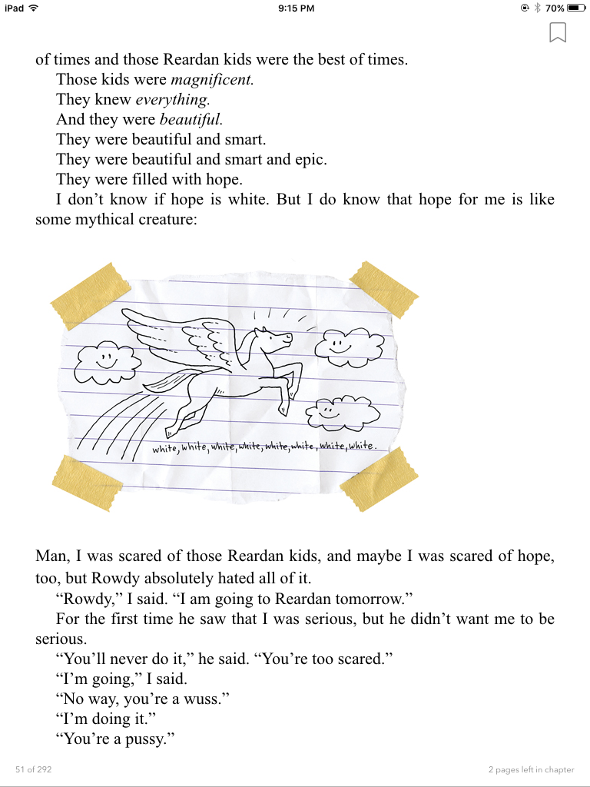
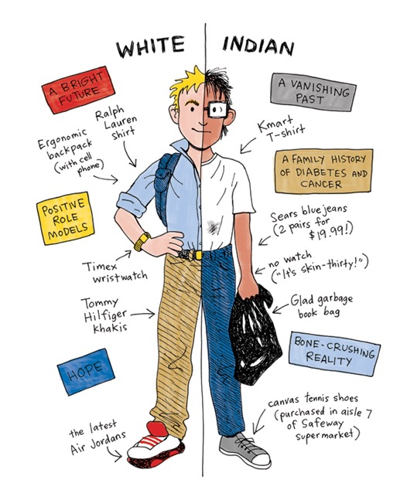
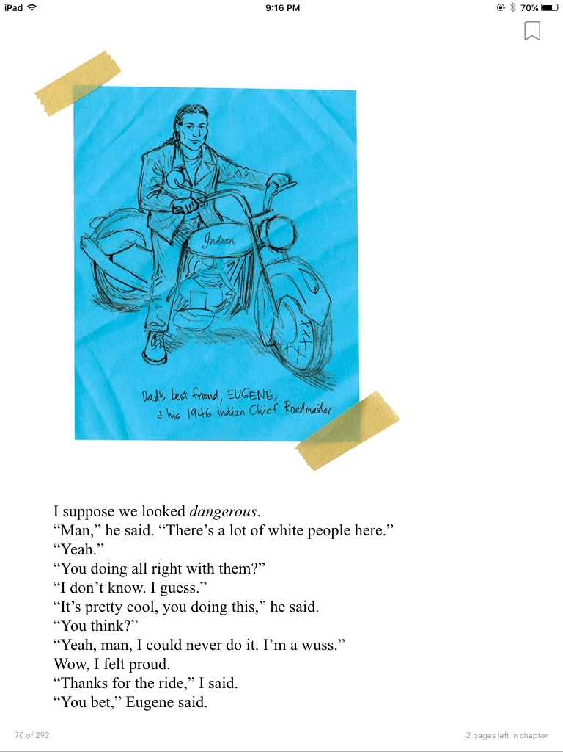

Kinney
- Illustrates exactly what is happening in the scene, only a few are explicitly drawn by Greg
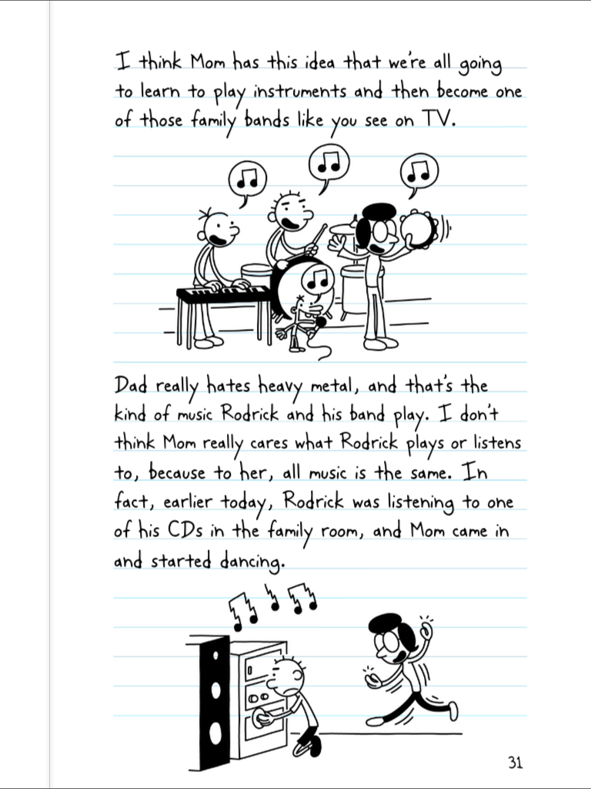
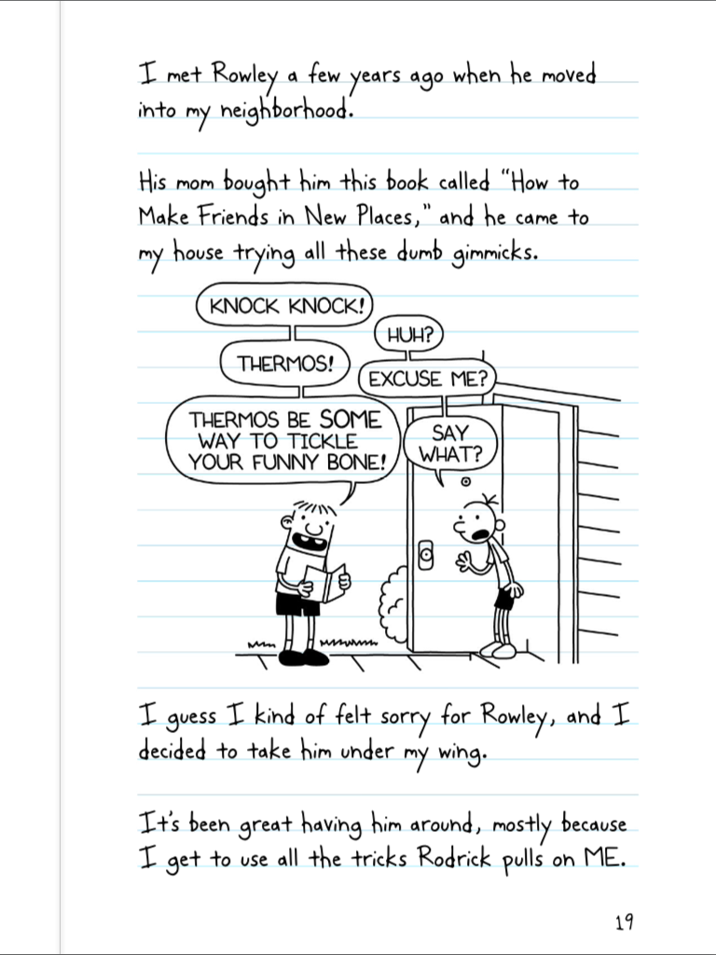
- Nearly all illustrations are done in the same style

Here are some guiding questions to ask students or base activities on relating to drawing and illustration:
- How do the pictures/drawings in each book further your understanding of the narrative? How do they complication your understanding?
- How could the illustrations be changed to better your understanding?

Concluding Ideas/Activities
After covering some or all of these topics, a great final activity would be to have students think about what they would include in their own ‘diary’ to translate the themes into their own lives and the world around them.11 What themes would they include? How would they represent their friends, family, school, or other important aspects of their lives? What role would race, class, and gender play? Who would they include in their narrative? Would they write about themselves now, or a past version of themselves? What sorts of drawings would they include and how would they be a part of the story? What major events would they write about? Would their story be more like Kinney’s or Alexie’s? What would the overall tone of their diary be?
If the class schedule allows, it would be a great opportunity for students to have they actually write at least a section of their diary. The length, extent of details, and other specific parameters may vary based on the grade, time available, and focus of the class. Having students do this provides them with an opportunity to reflect on how the topics in the two books relate to and are a part of their own lives. It would aid students in applying these concepts to their own writing and lives. Additionally, it might be a break from the academic or essay types paper students are accustom to writing.

Work Cited
Alexie, Sherman. Absolutely True Diary of a Part-Time Indian. Little, Brown and Company, 2007.
Bolt, Julie. "Hybrid Positioning and Student Agency in the Post-Colonial Americas: Why Teaching American Indian Literature Matters." Radical Teacher, no. 82, Aug. 2008, pp. 13-18. EBSCOhost, ezproxy.lib.ndsu.nodak.edu/login?url=https://search-ebscohost-com.ezproxy.lib.ndsu.nodak.edu/login.aspx?direct=true&db=eue&AN=97449764&site=ehost-live&scope=site.
Kaywell, Joan. Adolescent Literature as a Complement to the Classics. Christopher Gordon Publishers, 1993.
Kinney, Jeff. Diary of a Wimpy Kid. Amulet Books, 2007.
McGlinn, Jeanne. "Reading Native American Literature: A Teacher's Guide." Journal of Adolescent & Adult Literacy, vol. 48, no. 8, 2005, p. 721+. Educators Reference Complete, go.galegroup.com.ezproxy.lib.ndsu.nodak.edu/ps/i.do?p=PROF&sw=w&u=ndacad_58105ztrn&v=2.1&it=r&id=GALE%7CA132746298&asid=cc5f048ecc475686bad86dabba2822a8.
Metzger, Kenan, et al. “Embracing Intercultural Diversification: Teaching Young Adult Literature with Native American Themes.” The English Journal, vol. 102, no. 5, 2013, pp. 57–62. JSTOR, JSTOR, www.jstor.org/stable/24484093.
Zitzer-Comfort, C. "Teaching Native American Literature: Inviting Students to See the World through Indigenous Lenses." Pedagogy, vol. 8 no. 1, 2008, pp. 160-170. Project MUSE, muse.jhu.edu/article/229022.

